Operating System- Assignment 1

Name: Sayali Prabhudas Wagh Div – D Roll No.: 67

1. Display the system’s date.

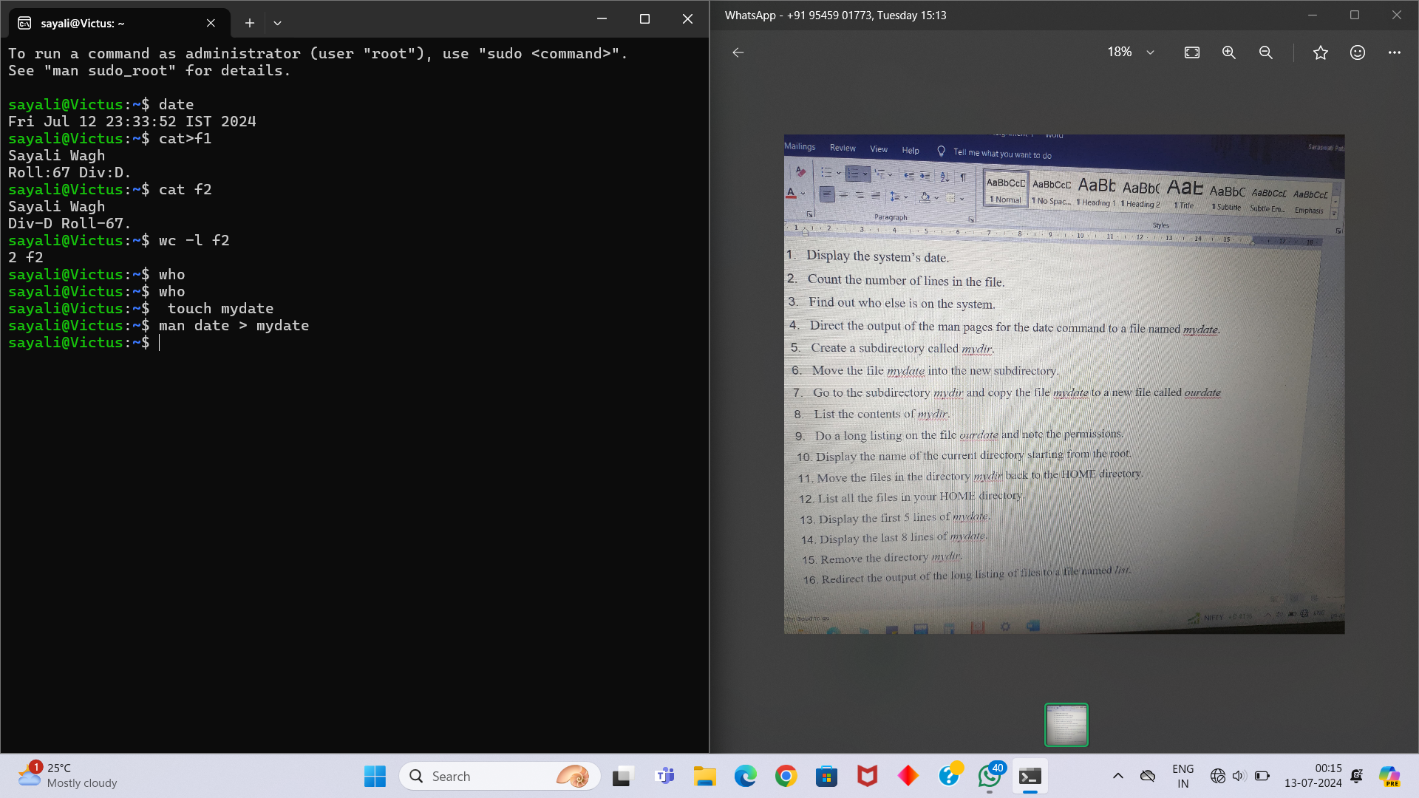

1. Count the number of lines in the /etc/passwd file.

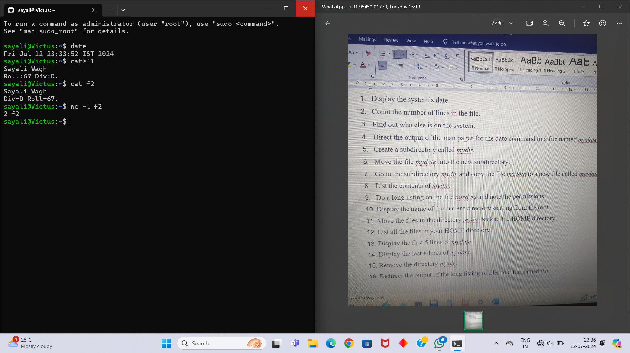

1. Find out who else is on the system.

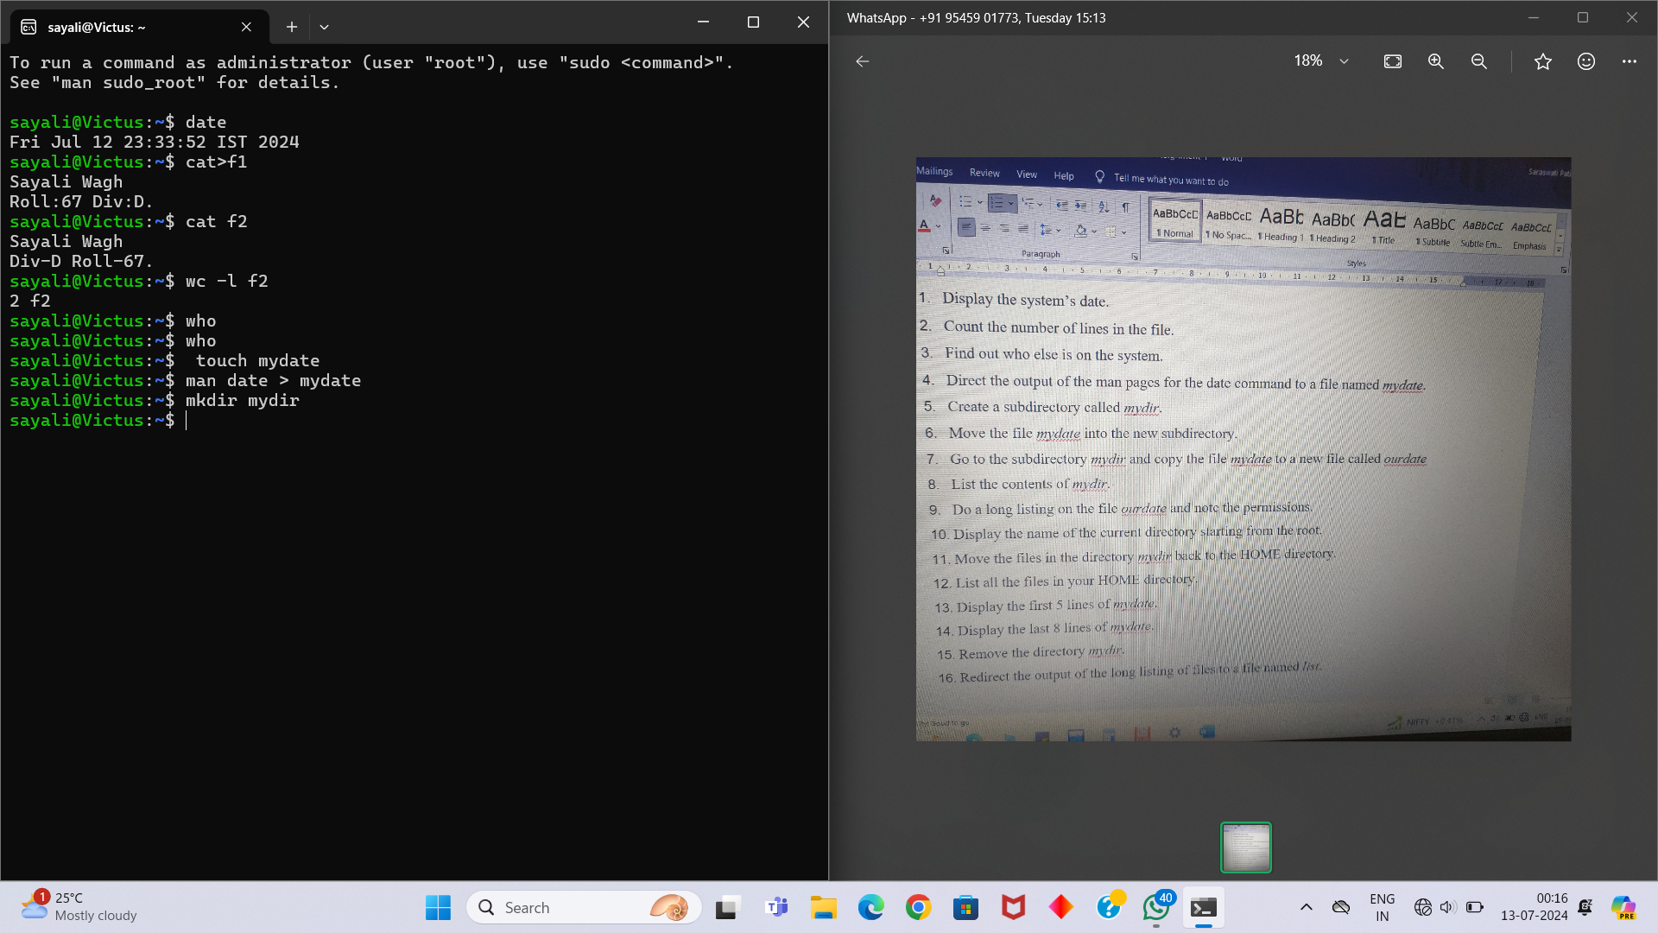

1. Direct the output of the man pages for the date command to a file named mydate.

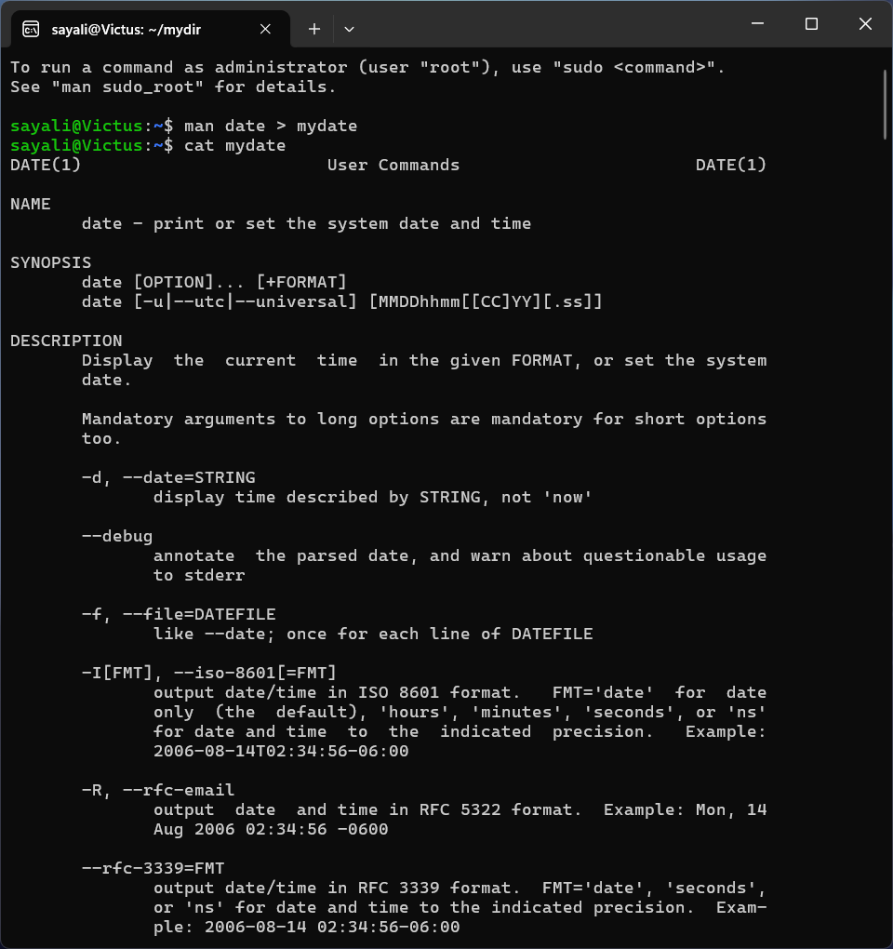

1. Create a subdirectory called mydir.

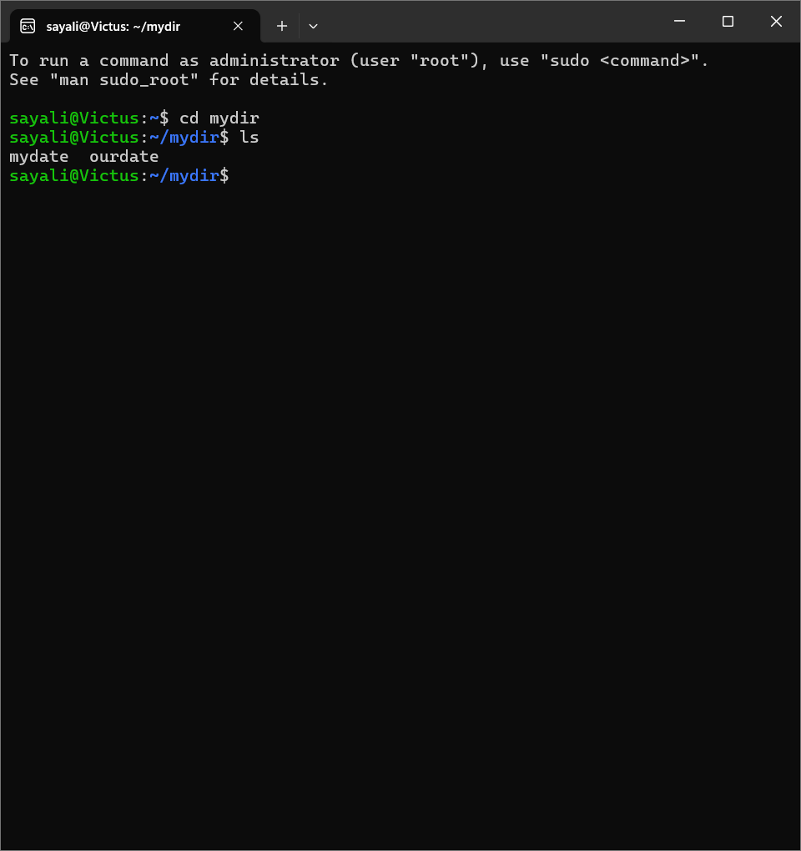

1. Move the file mydate into the new subdirectory.

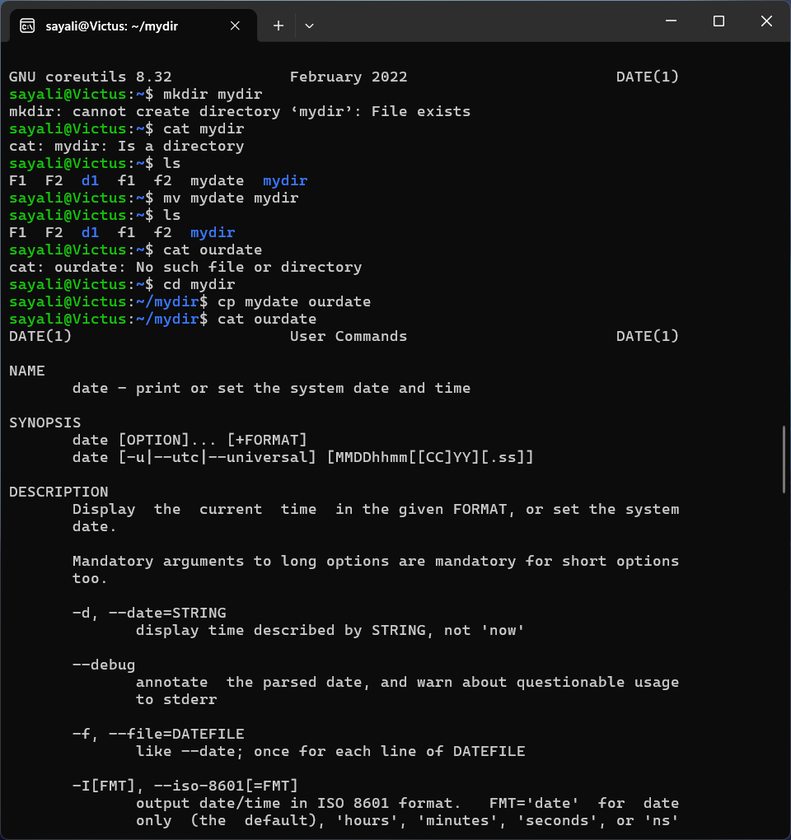

1. Go to the subdirectory mydir and copy the file mydate to a new file called ourdate.



1. List the contents of mydir.

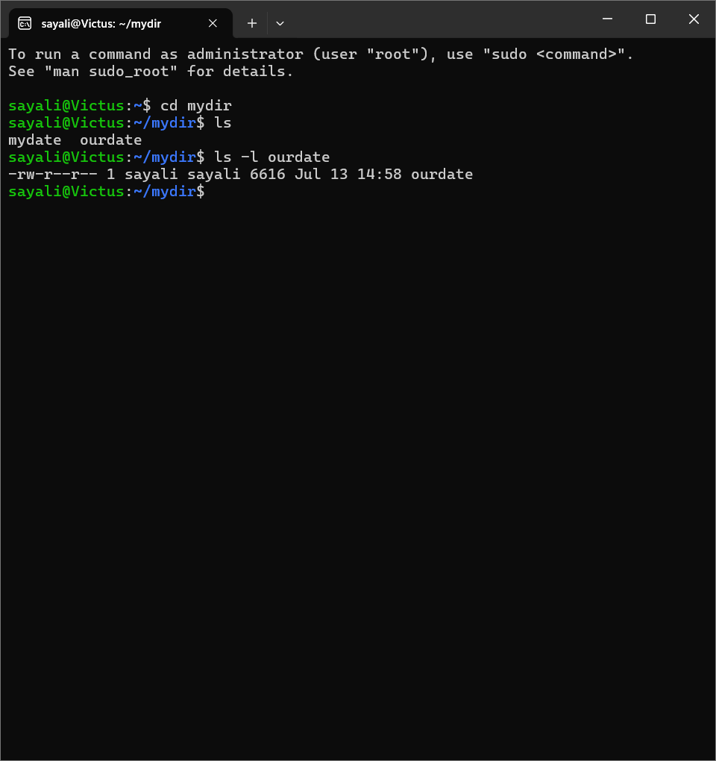

1. Do a long listing on the file ourdate and note the permissions.



1. Display the name of the current directory starting from the root.

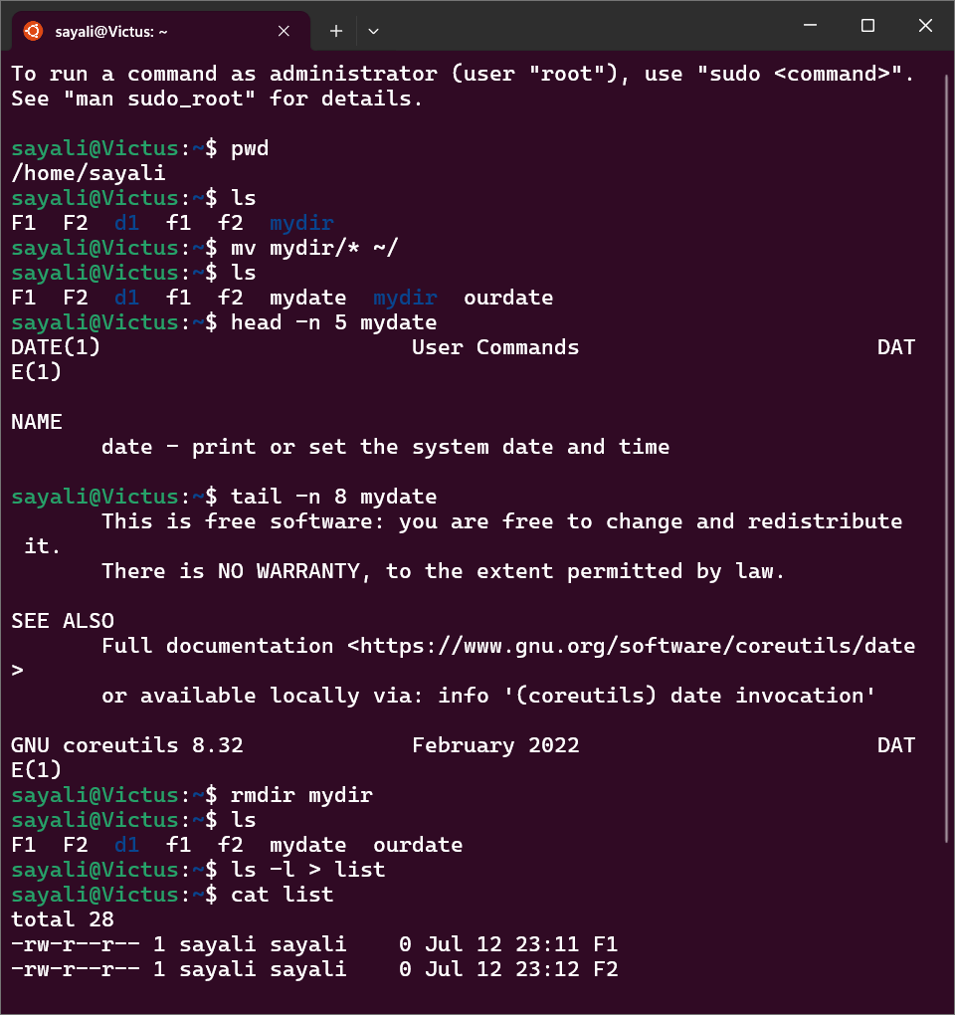

1. Move the files in the directory mydir back to the HOME directory.



1. List all the files in your HOME directory.



1. Display the first 5 lines of mydate.



1. Display the last 8 lines of mydate.



1. Remove the directory mydir. 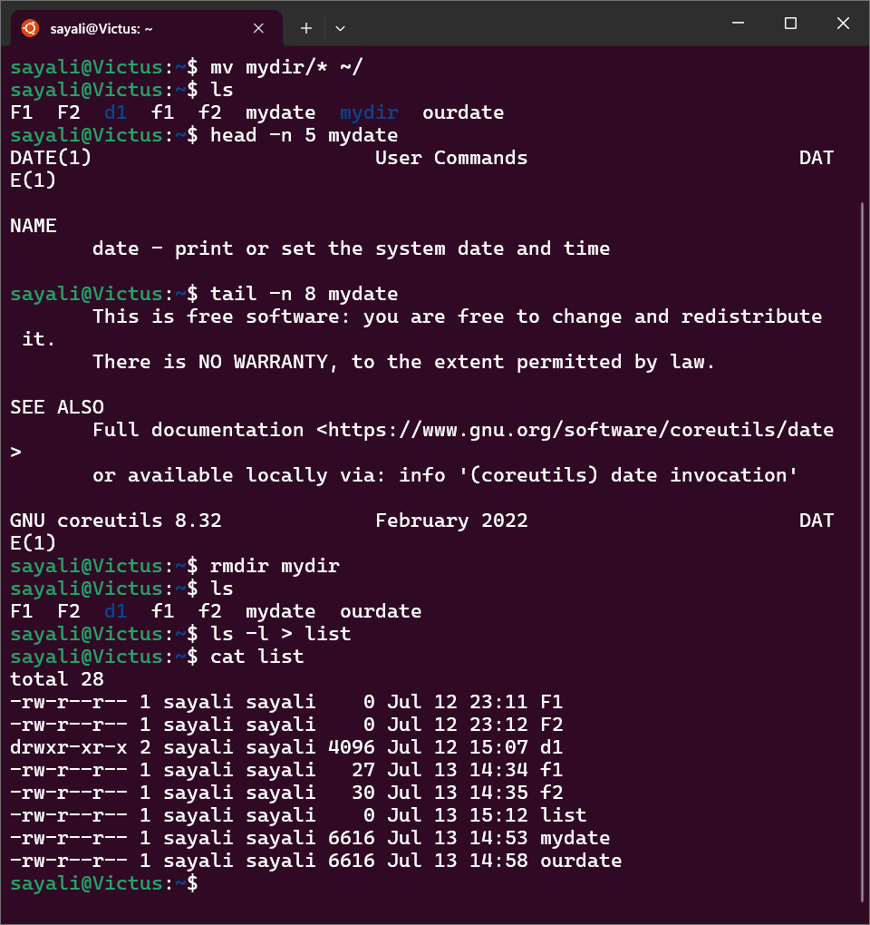
2. Redirect the output of the long listing of files to a file named list.

